ME2104: Mechanical Analysis and Design

DAE2: Design and Selection of Mechanical Elements

CW Solutions
Questions 3,4,6,8,10,15

Prepared by: Student

Date

Question 3, Lecture 1:
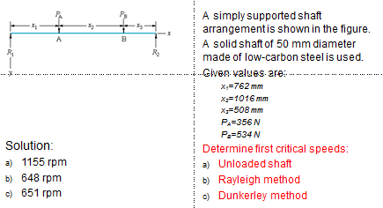
Solution of Q3:

Question 4, Lecture 1:
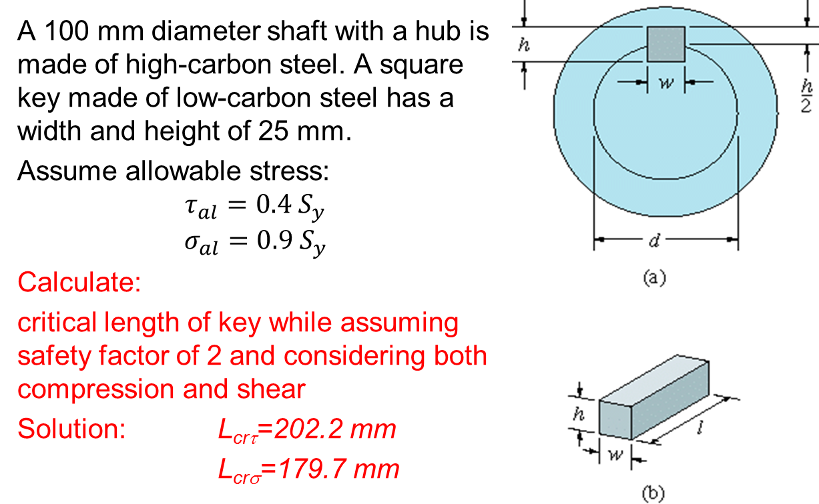
Solution for Q4:

Question 6, Lecture 2:
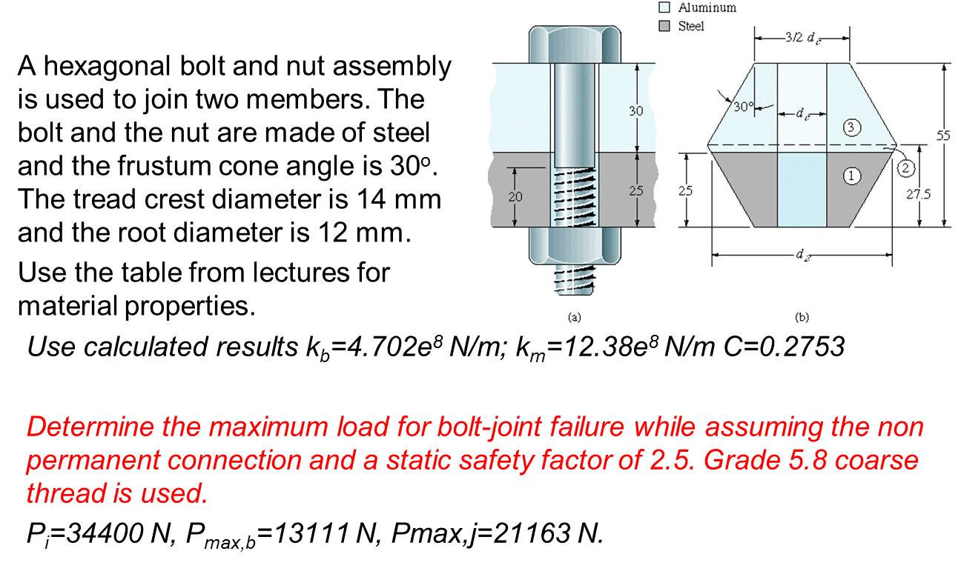
Solution for Q6:

Question 8, Lecture 3:
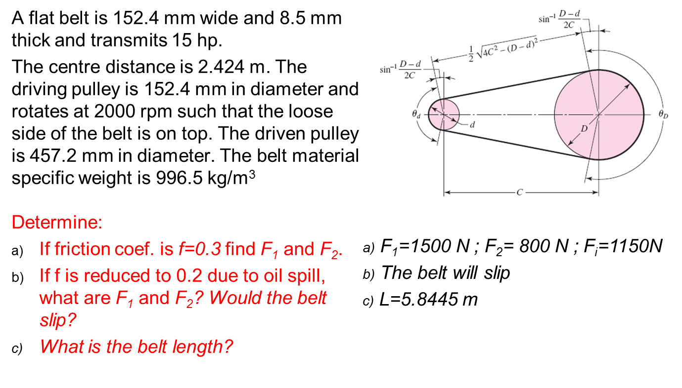
Solution of Q8:

Question 10, Lecture 3:
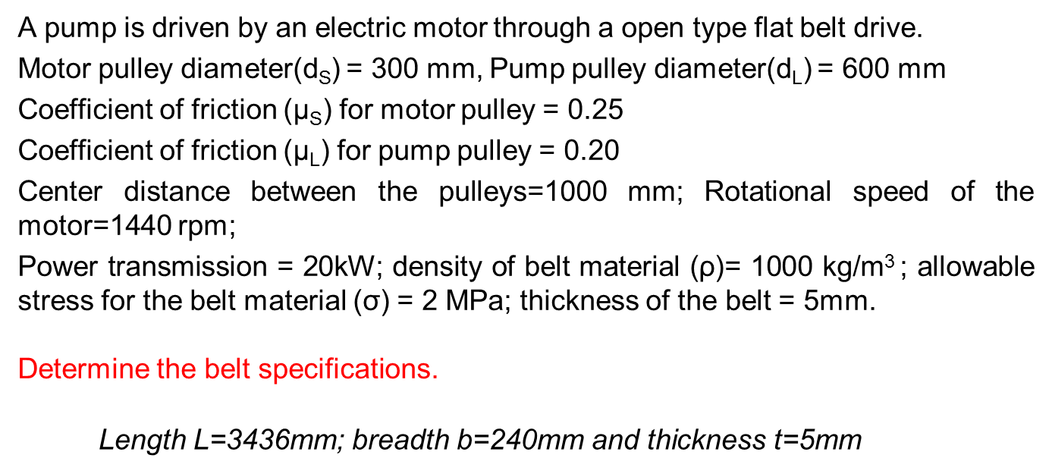
Solution for Q10:

Question 15, Lecture 4: 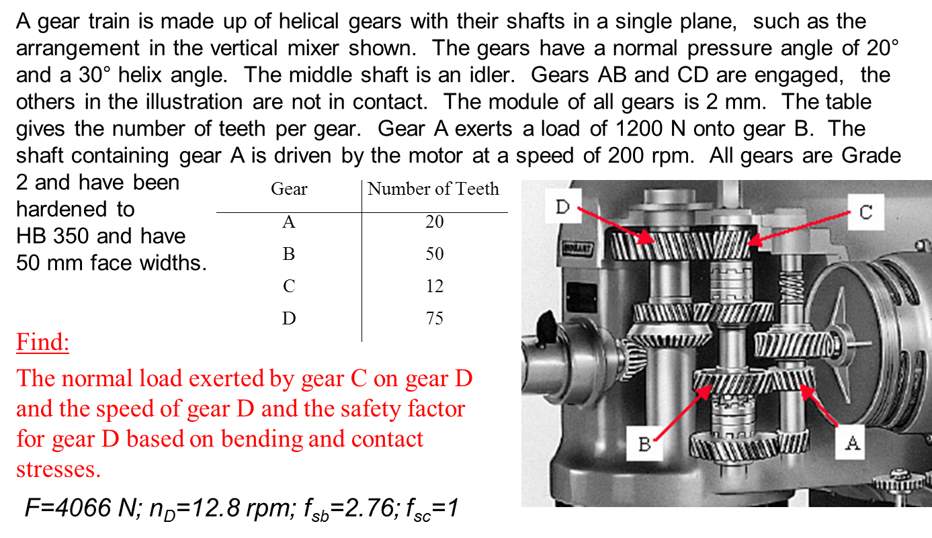
Solution for Q15:

