EXAM A: SOLUTIONS

QUESTION 1
i) Taking x=A4 one possible solution is: (10 points)

f(-2)=1 and f(5)=2|5-3|=4. (2.5 points)

ii)
2 for -2  x  2
f(x) = x for x  -2
4-x for x  2 (8 points)

(4.5 points)

QUESTION 3:
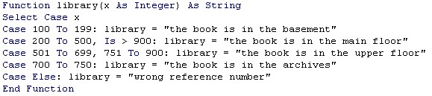(2 points for defining variable types, 2 points for correct select case structure, 3 points for each of the seven cases)

QUESTION 2 :
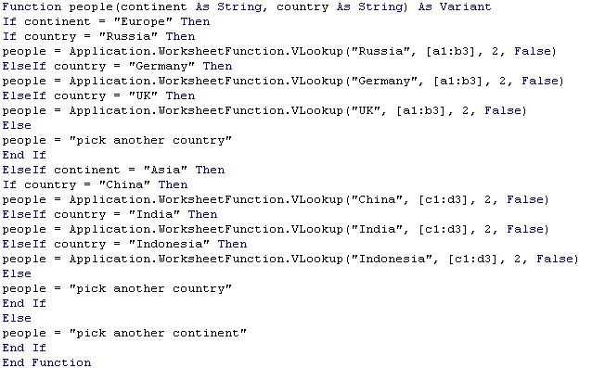
(2 points for defining variable types, 5 points for the outer if structure, 9 point for each of the two inner if structures)

QUESTION 4:
i)
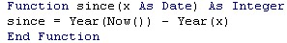 (7 points)
ii) 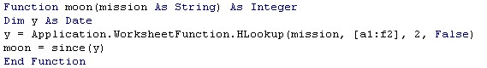
(9 points)
iii)
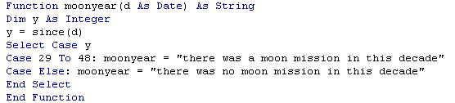
(9 points)

