EXAM B : SOLUTIONS

QUESTION 1
i) Taking x=A4 one possible solution is: (10 points)

f(-8)=-1 and f(10)=|8-10|=2. (2.5 points)

iii)
x for 0  x  4
f(x) = (x+4)/2 for x  4
0 for x  0 (8 points)

(4.5 points)

QUESTION 3 :
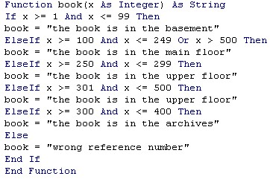
(2 points for defining variable types, 2 points for correct if structure, 3 points for each of the seven cases)

QUESTION 2 :
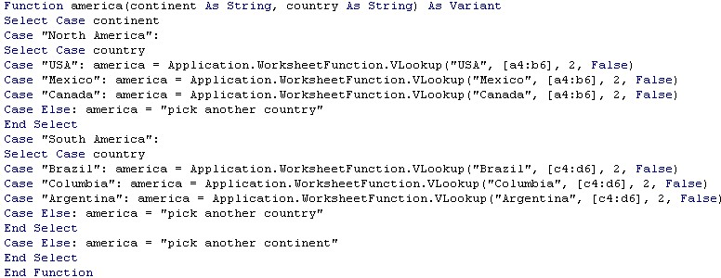
(2 points for defining variable types, 5 points for the outer if structure, 9 point for each of the two inner if structures)

QUESTION 4 :
i)
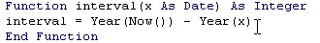(7 points)
ii) 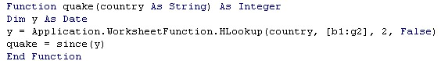
(9 points)
iii)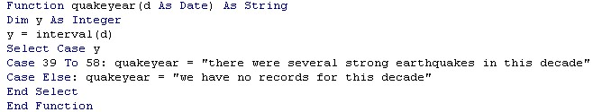
(9 points)

