The Growth in the Numbers of NGOs Accredited to
the UN Economic and Social Council in Each Year

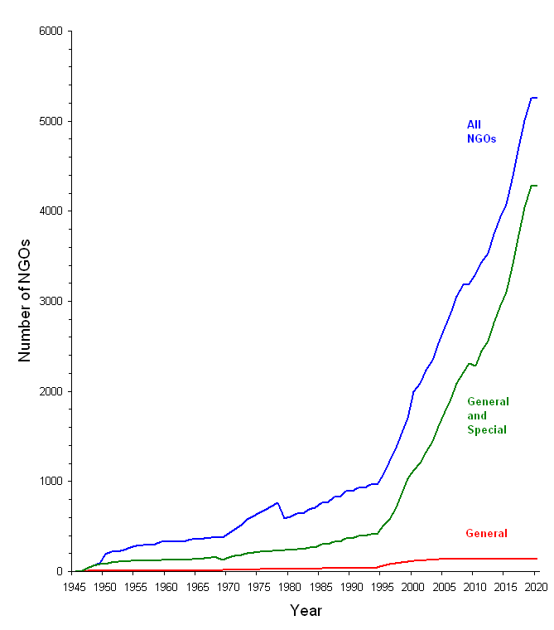
General Status: having a large membership and working on most ECOSOC questions
Special Status: large regional/national NGOs or specialist NGOs of high status
All NGOs: including also the ECOSOC Roster of small or very specialist NGOs

This graph may be freely used and reproduced, provided that the author’s name and the web page, are cited as follows
Peter Willetts, “Information on Consultative Status for NGOs with the UN Economic and Social Council”, at www.staff.city.ac.uk/p.willetts/NGOS/NGO-HOME.HTM#CSECOSOC
In addition, if use is desired for commercial purposes, the author should be informed (P dot Willetts at city dot ac dot uk), but no charge will be made.
Complete lists of all NGOs accredited to ECOSOC, for each year from 1999 to 2019, are also available from links at www.staff.city.ac.uk/p.willetts/NGOS/NGO-HOME.HTM#CSECOSOC
© Peter Willetts, 26 May 2022.

