File locations for CATIA course

Exercise can also be accessed directly from the Catia workbench by pressing:
Help/ Contentc, Index and Search
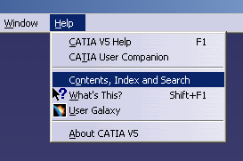
after that press buttons as outline below for each of these exercises

Part Design: Tutorial 1 

Mechanical/ Part Design/ Getting Started

Assembly Design: Tutorial 2 

Mechanical/ Assembly Design/ Getting Started

Wireframe & Surface: Tutorial 3 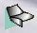

Mechanical/ Wireframe and Surface/ Getting Started

Generative Drafting: Tutorial 4 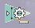

Mechanical/ Generative Drafting/ Getting Started

Interactive Drafting: Tutorial 5 

Mechanical/ Interactive Drafting/ Getting Started

Generative Part Structural Analysis: Tutorial 6 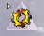

Analysis/Generative Structural Analysis/ Getting Started

Parameters and Formulas : Tutorial 7

Mechanical/Parameters and Formulas / Getting Started

